Automated Lead Scraping and Email Outreach System

Lead Automation Command Center - Dashboard:
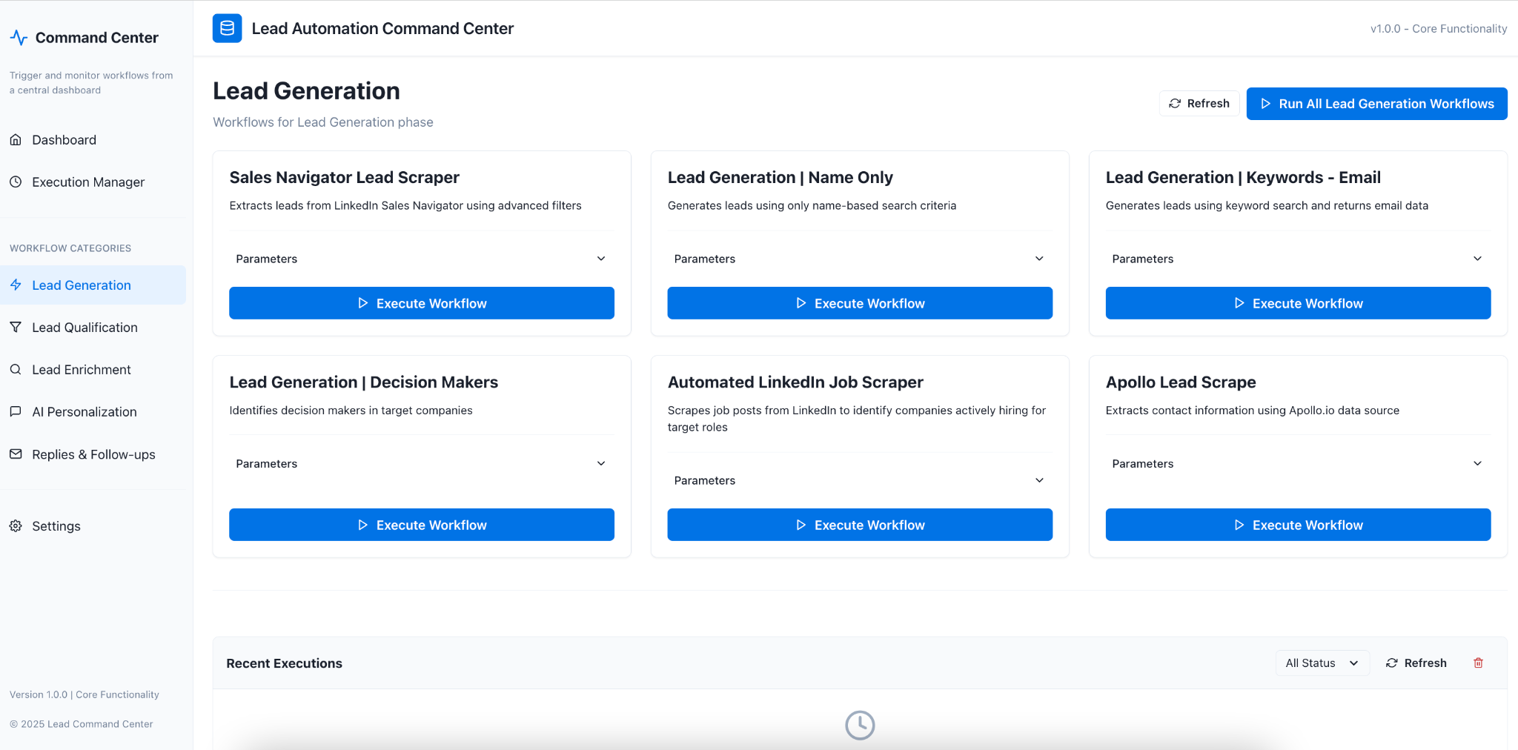

Lead Automation Command Center - Execution Manager:
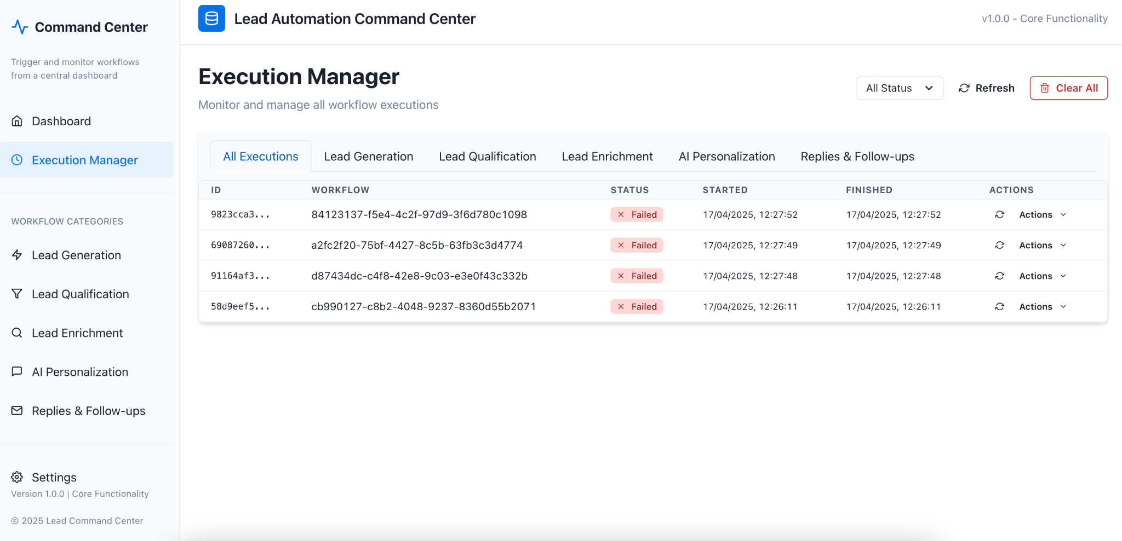

Lead Automation Command Center - Settings:
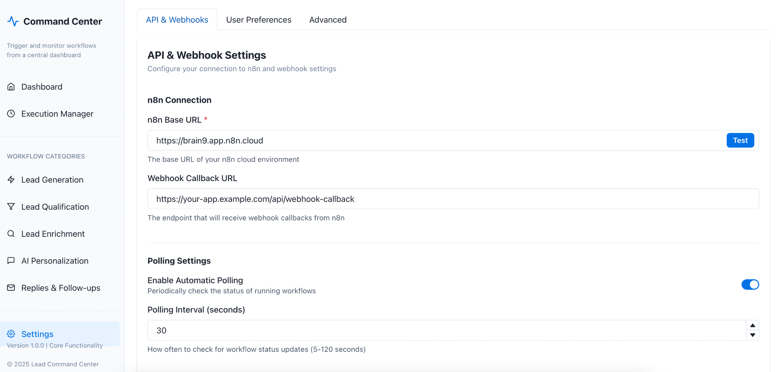

N8n Workflows:

1 - Lead Generation

Sales | LG | LinkedIn Job Scraper
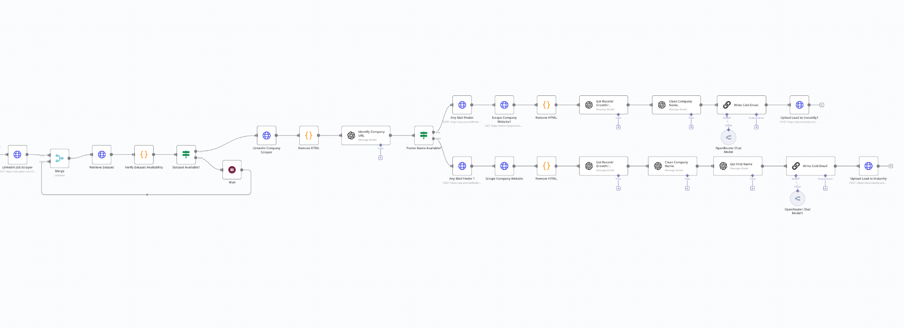

Sales | LG | Apollo Lead Scraper
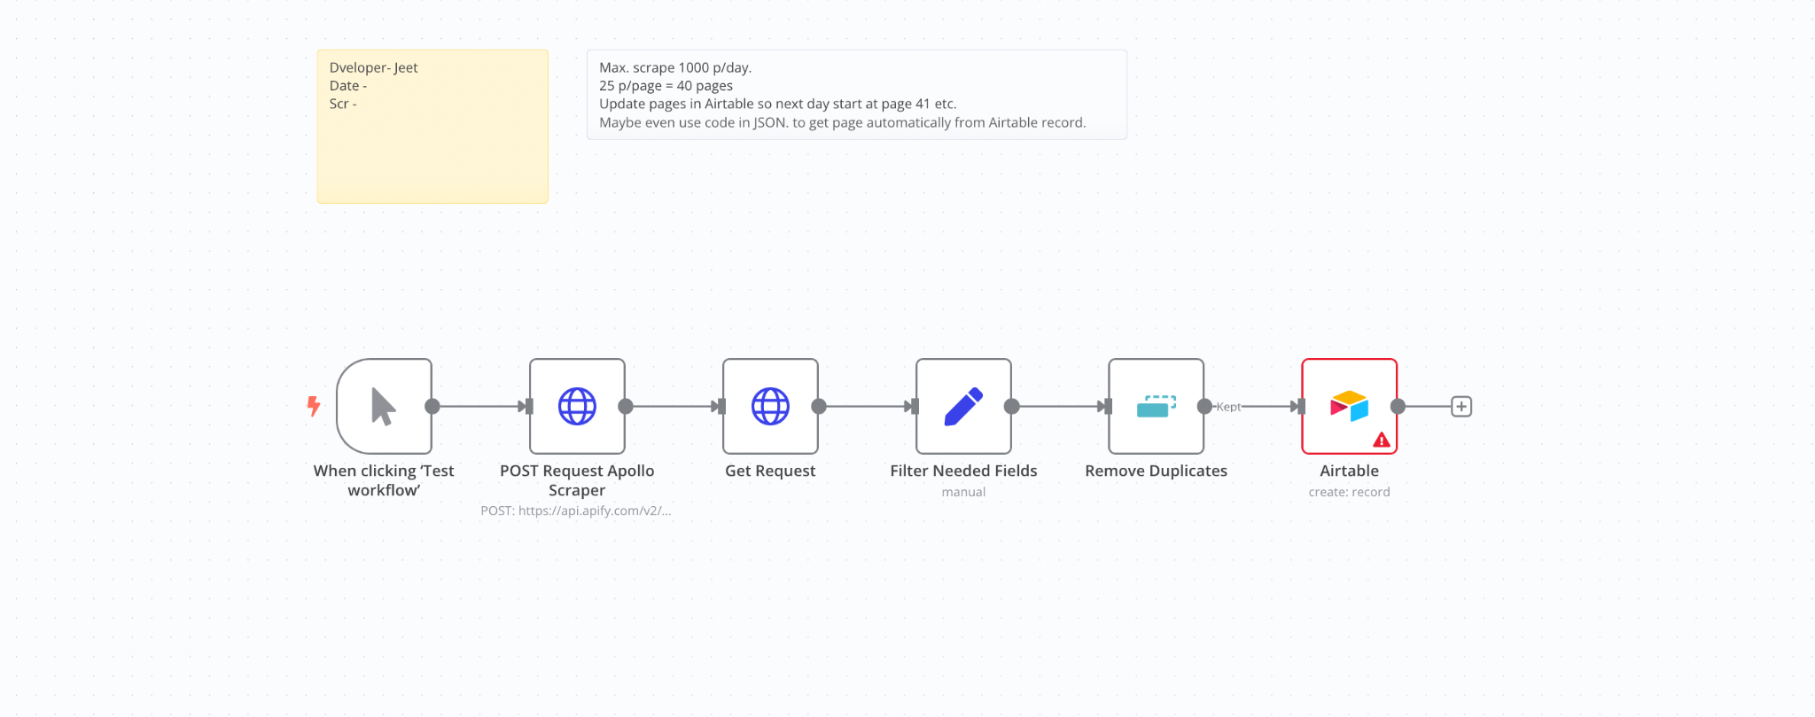
Sales | LG | Sales Navigator Lead Scraper
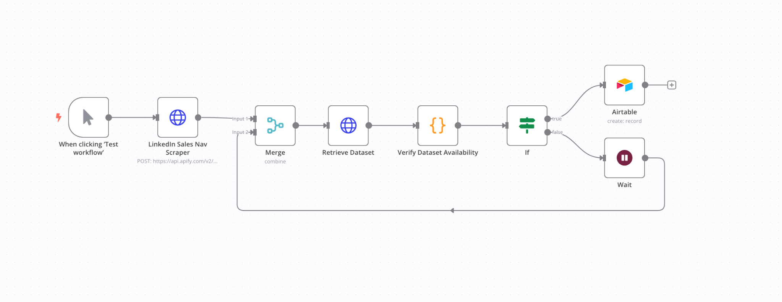
Sales | LG | Name Only
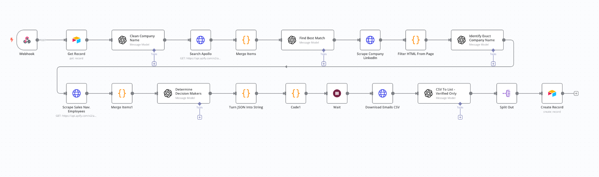
Sales | LG | Decision Makers
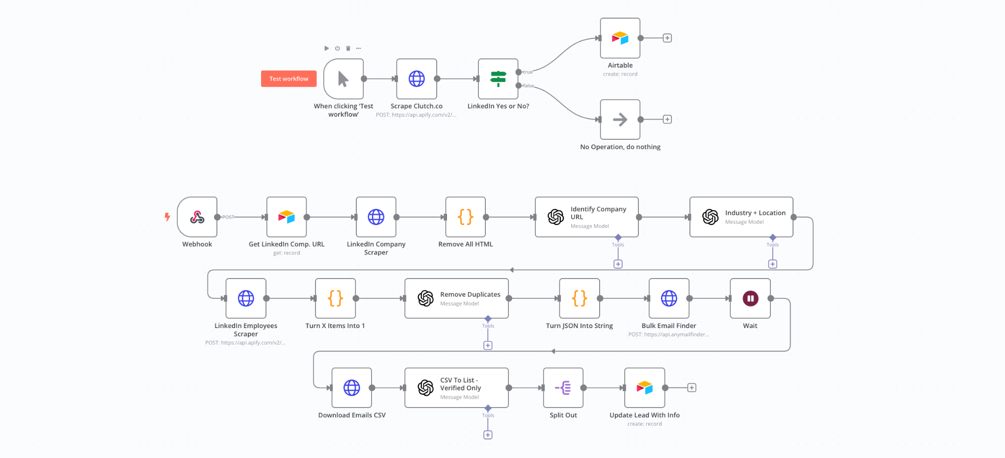
Sales | LG | Automation System LinkedIn Job Scraper
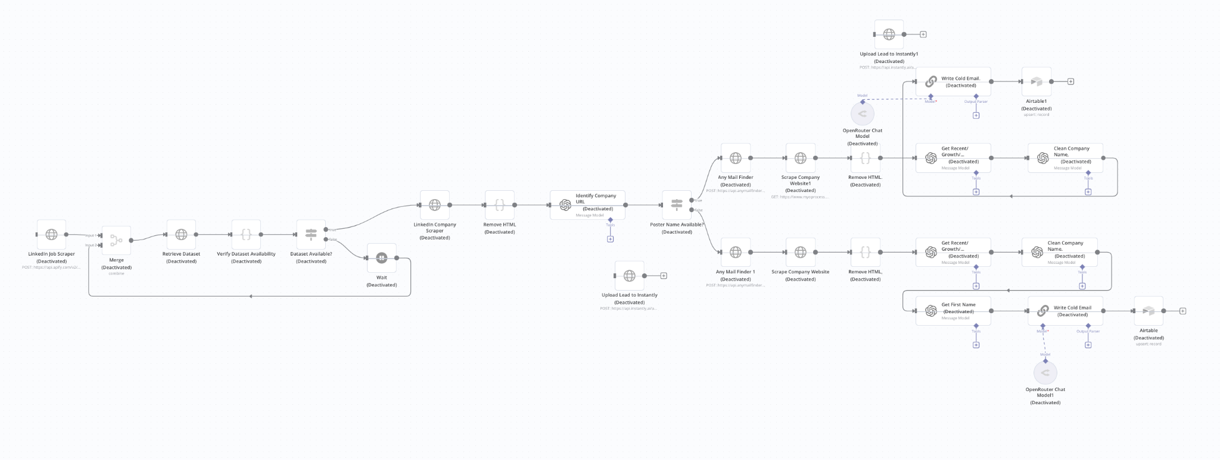

2 - Lead Qualification

Sales | LQ | Personalization
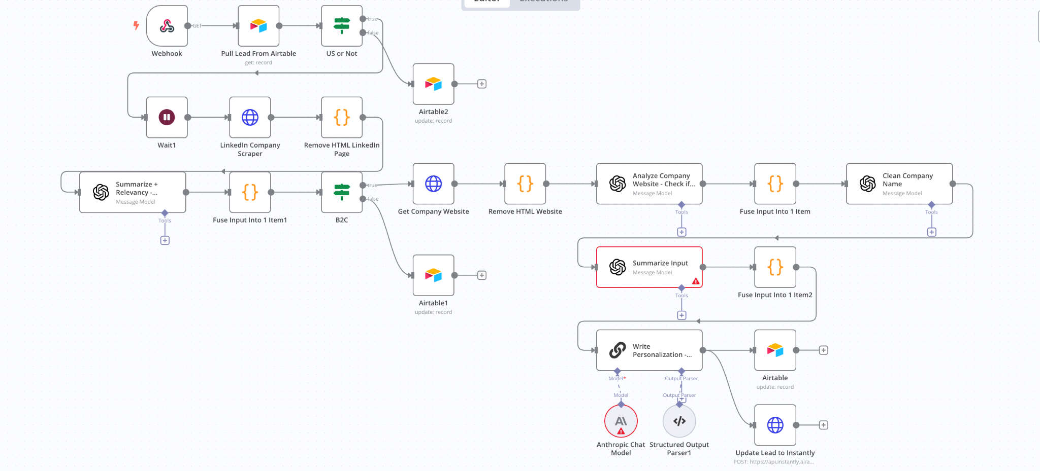
Sales | LQ | 3-Step Lead Qualification
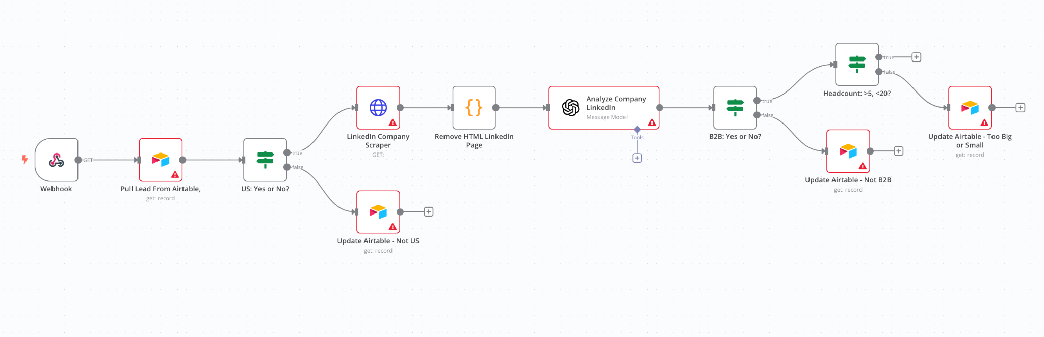
3 - Lead Enrichment
Sales | LE | LinkedIn
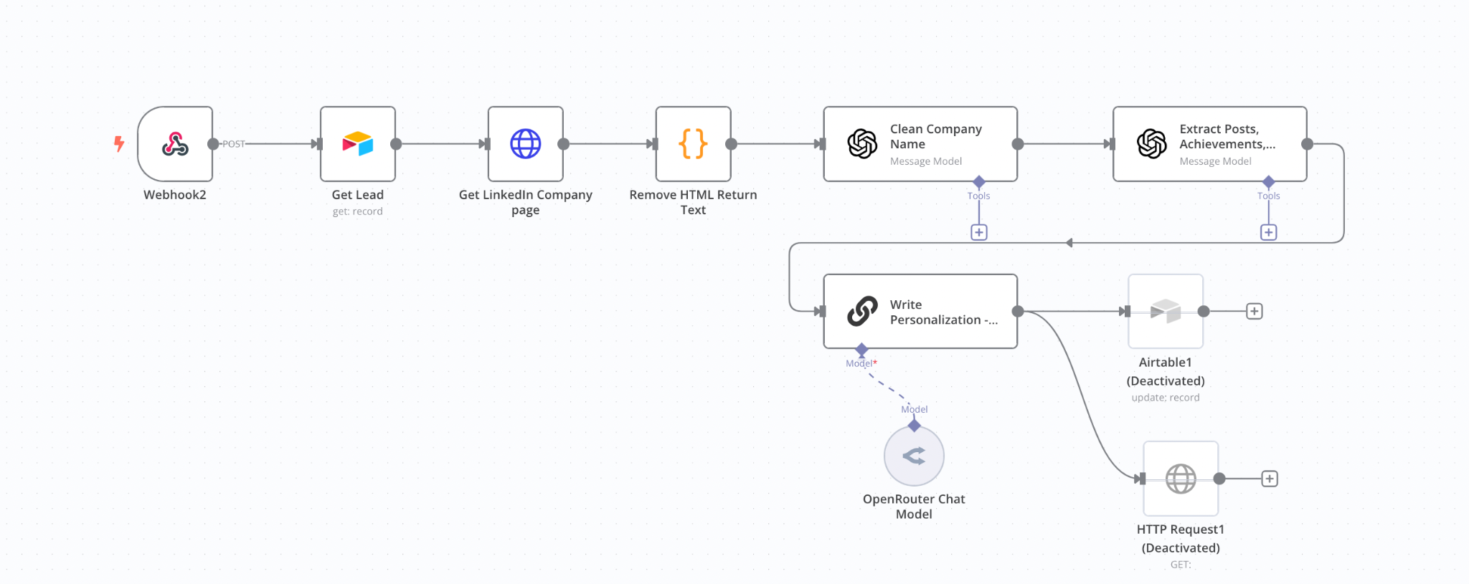
Sales | LE | Scrape + Enrich
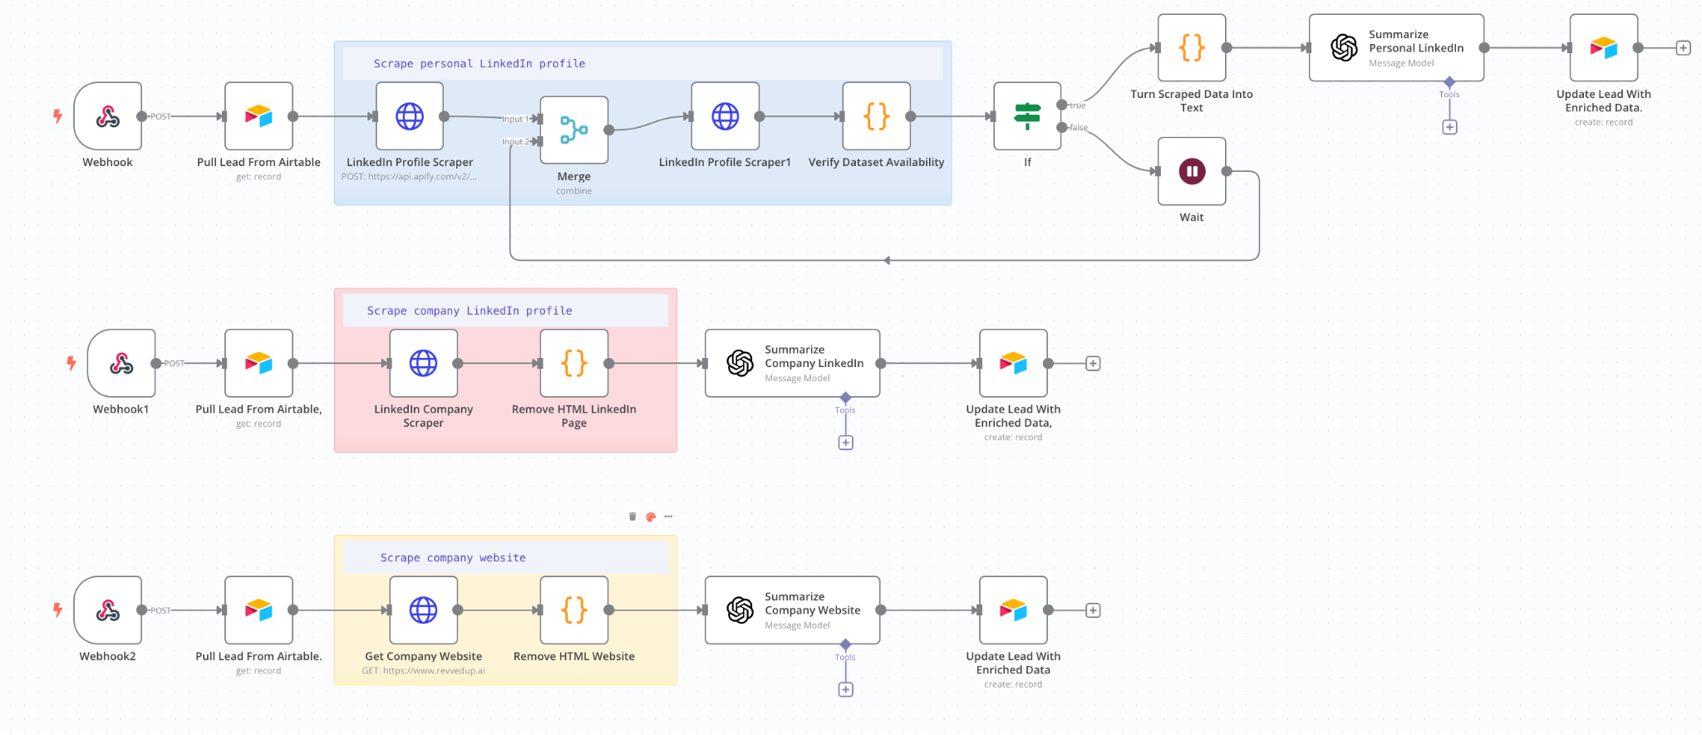
Sales | LE | LinkedIn Personalization
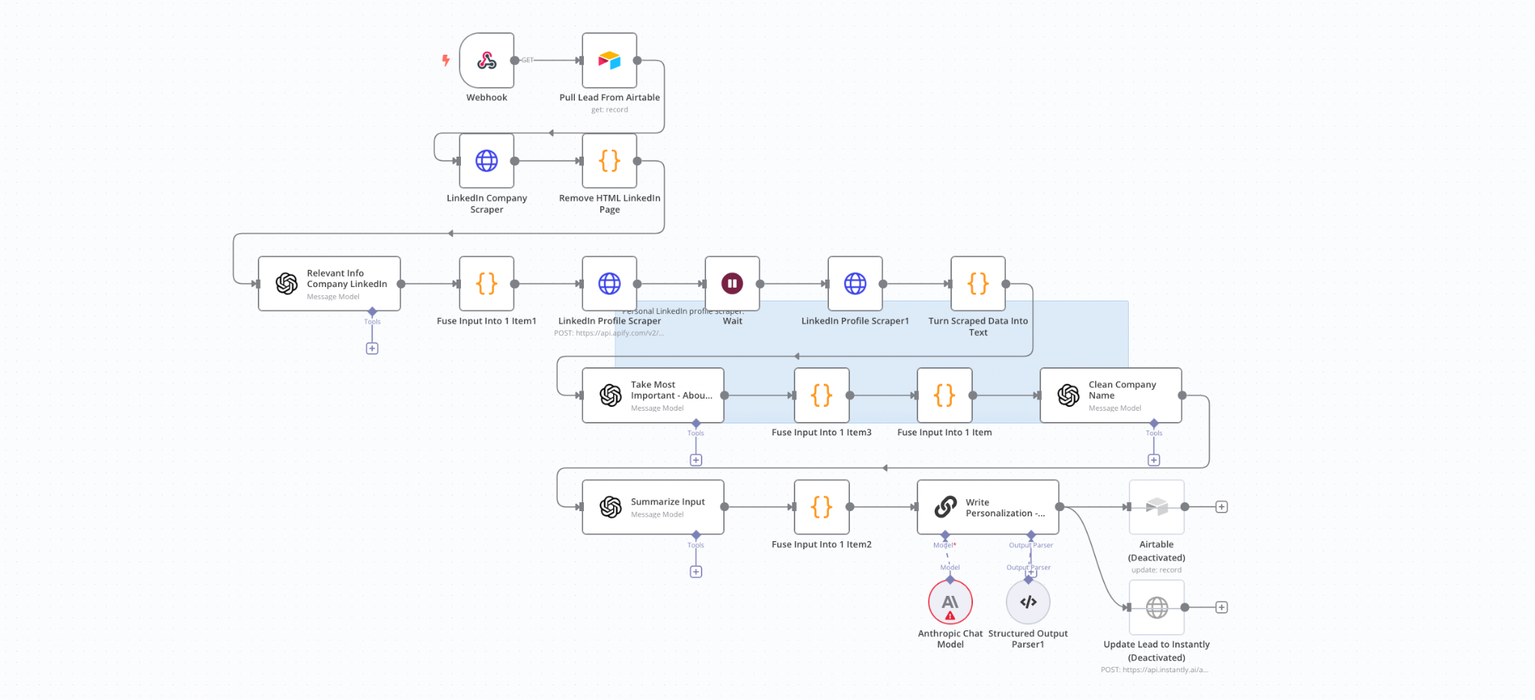
Sales | LE | Company Website Smart Crawler
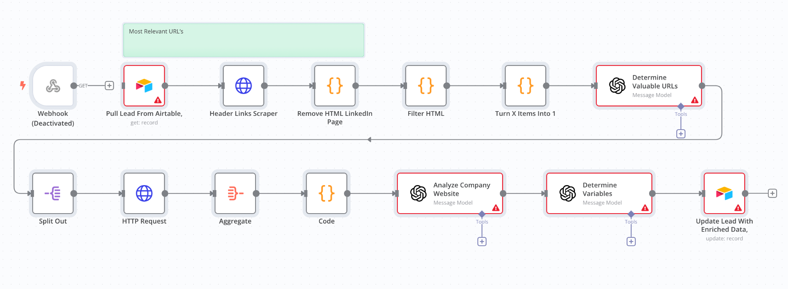
Sales | LE | Enrichment Website Sections
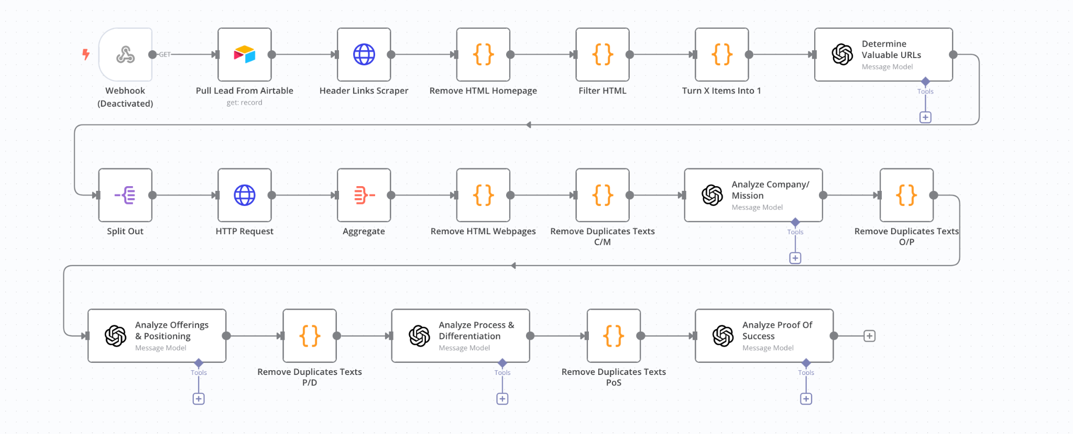
4 - AI Personalization

Sales | AP | Deep Insights - About Page
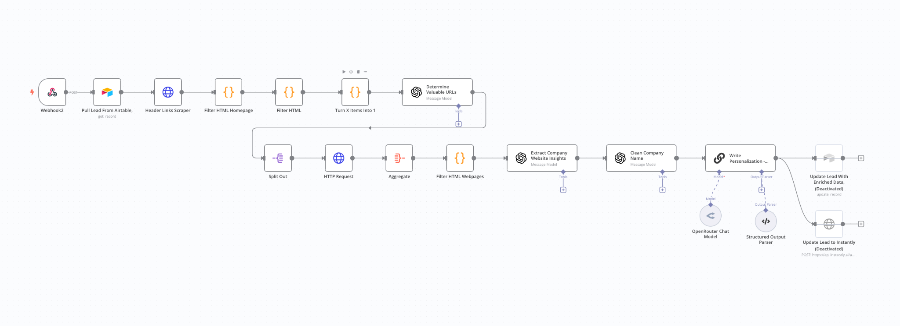
Sales | AP| LinkedIn Post | Personal + Company
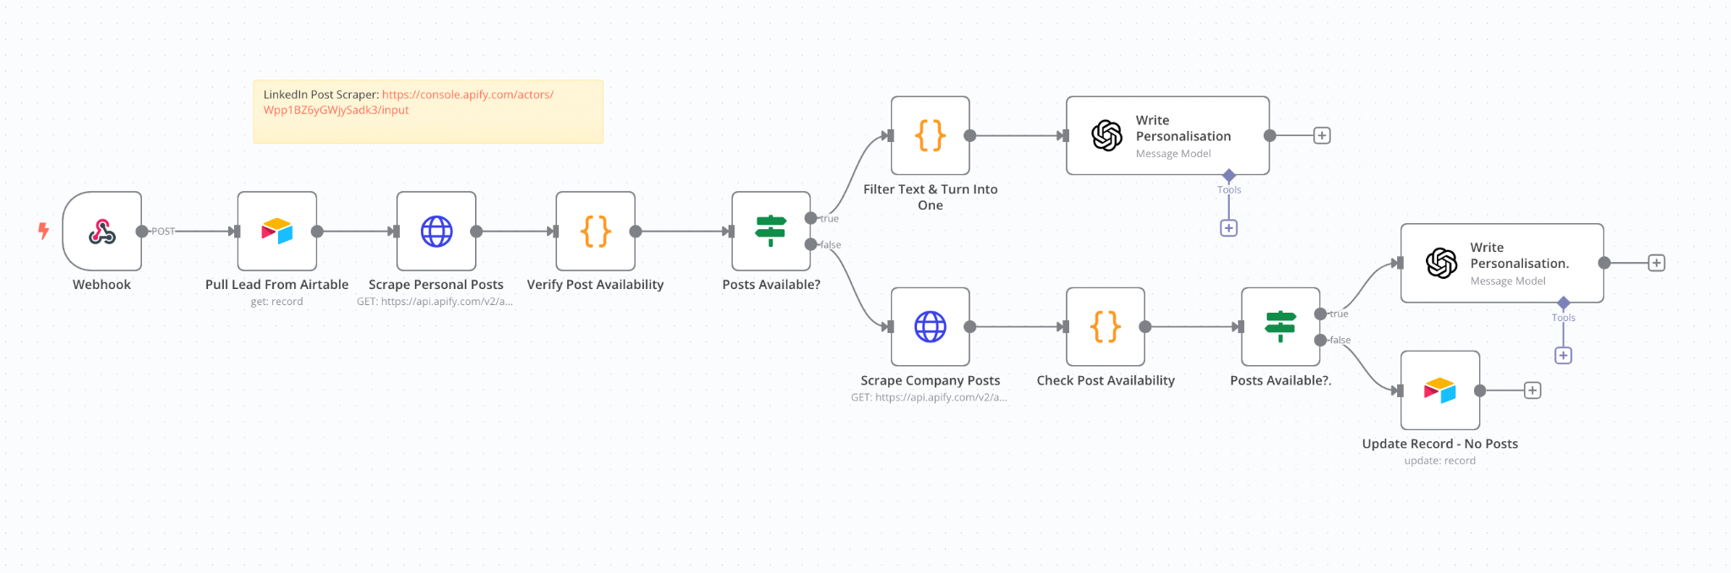

Sales | AP | AI Personalization | 3 Snippets
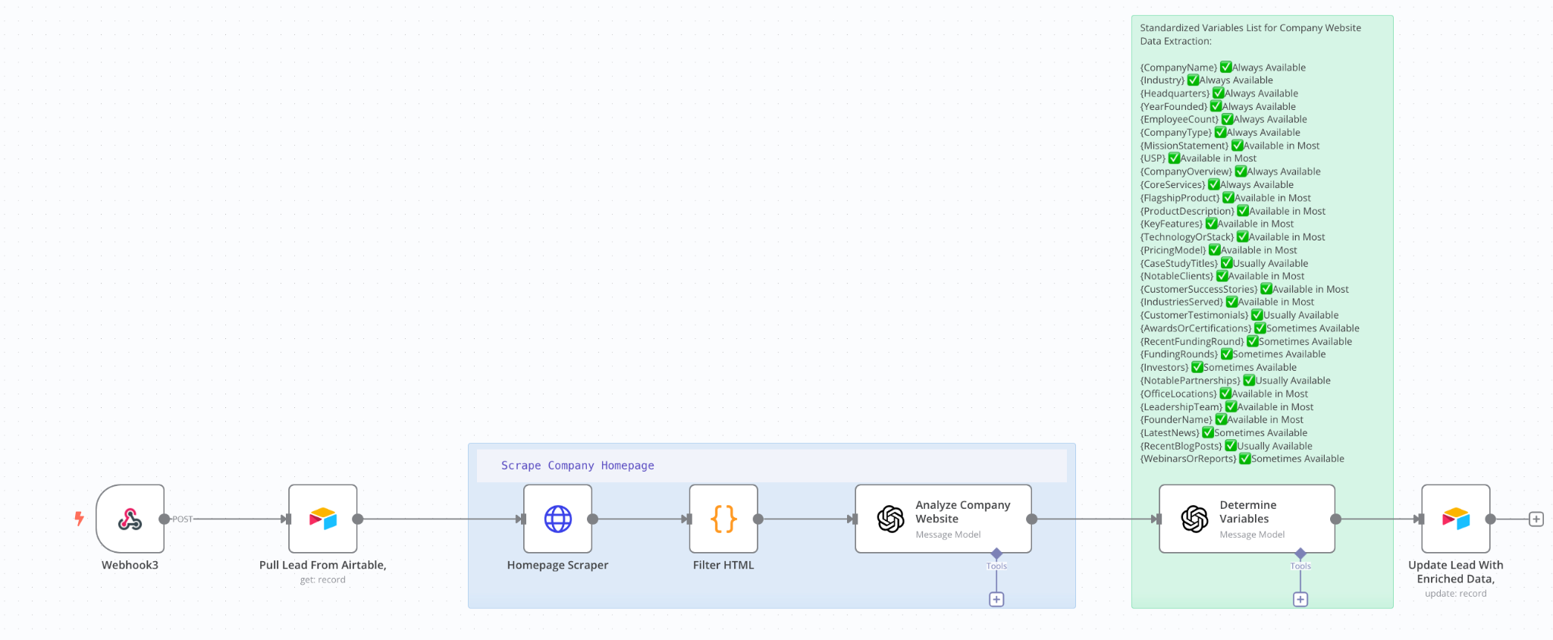

Sales | AP | AI Personalization | Departments
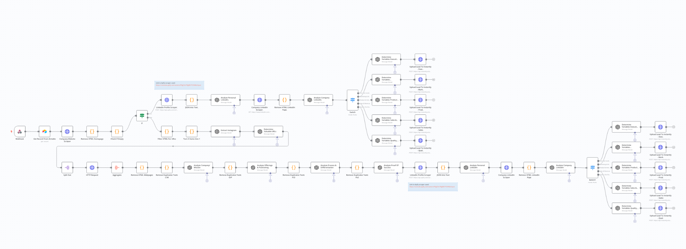
5 - Replies & Follow-ups

My Sales | R&F | AI Personalization | Departments 35
